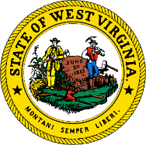
West Virginia Human Rights Commission
Youth Ambassador Program Application
To be considered for the Youth Ambassador Program, you must be 14-21 years of age and a resident of one of the following counties: Boone, Cabell, Kanawha, Lincoln, Logan, Mingo or Putnam. Applications must be received by March 19, 2020.

Name: _____________________________________________________________
Address: ____________________________________________________________
E-Mail: ___________________________ Phone: _________________________
County of Residence: _____________________________________
School Currently Attending: ________________________________ Grade: _____

Training will be held on the campus of West Virginia State University on March 26, 2020.

Short Answer/Essay Questions (150-250 words each)
- How do you think being an advocate for human rights for all would benefit not only others, but yourself?
- How do you think gaining knowledge on the topic of human rights could shape your thinking going forward?
- How do you plan on using the knowledge gained as a Youth Ambassador to improve your school or community?

Submit applications by US Mail or email to:
James Westbrook
West Virginia Human Rights Commission
1321 Plaza East, Suite 108A
Charleston, West Virginia 25301
James.R.Westbrook@wv.gov

